**REPORT- CREATE WORK AUTOMATION GPT**

**INTRODUCTION**

In this report we will discuss creation,deployment,business impact of Classify,Generate GPT using the tool – Linq [1]

**COMPANY NAME**

I have chosen **Walmart** to create,deploy classify,generate GPT for this project

**BUSINESS CAUSE/REASON**

Walmart faces major competition from its competitor like Amazon, target etc. Amazon’s leadership principle is centered around customer obsession and it is rapidly transforming its technology around customer support.

I want to make use of Classify, generate GPT to revolutionize walmart’s customer support and **streamline** workflow and improve revenue

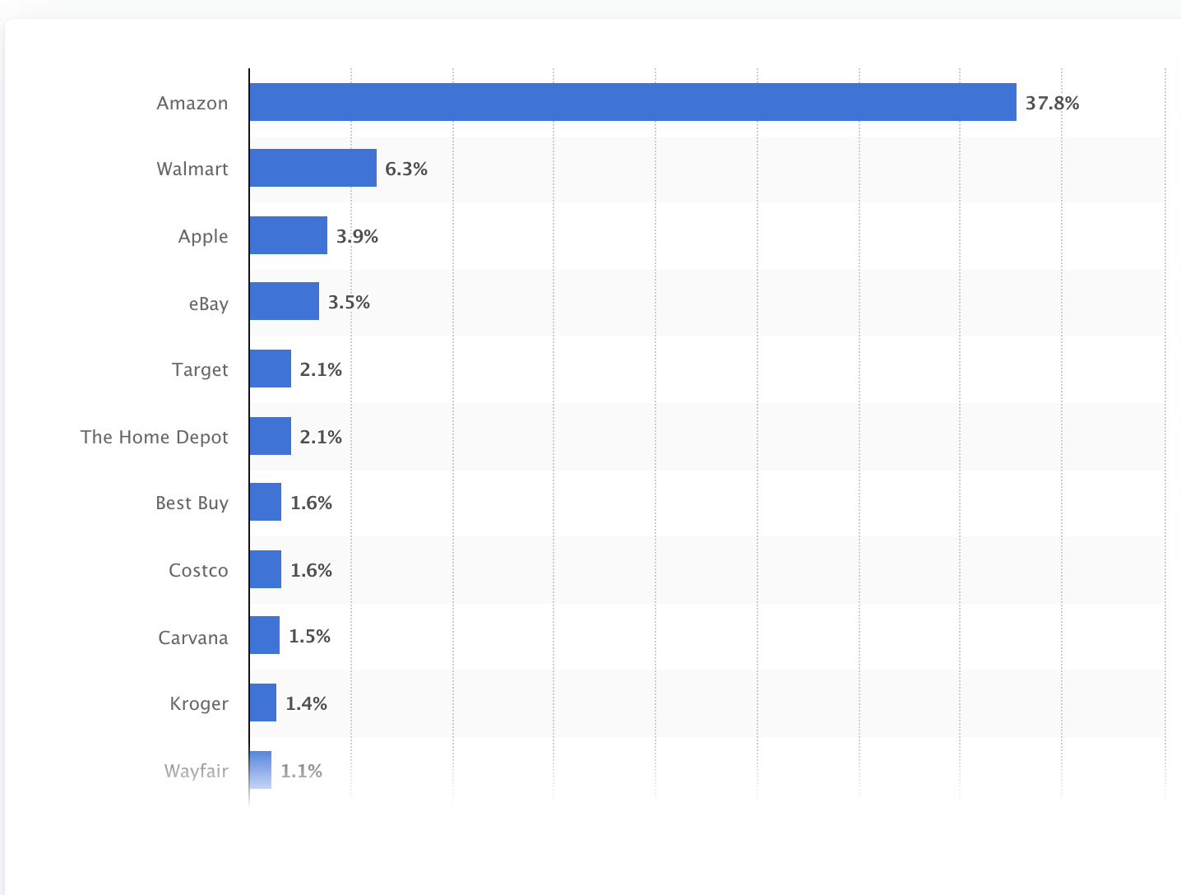

Fig1: Market share of leading retail e-commerce companies in the United States as of June 2022

From the above figure [2] we can conclude that walmart needs to improve their ecommerce workflow management to stay relevant in the market.

**CLASSIFY GPT**

Firstly we will focus on classify GPT . We will later build a **workflow** combining classify,generate functions in Linq ,so for that we need our system to classify reviews as positive or negative.

We design our system using the following setting in Linq

* **Parameter Setting:** used classify from create unit(default)
* **Model Type :** gpt 4
* **Temperature setting :** 0 (as we want LLM to be specific)
* **Embedded document (please attach the actual file with your assignment) :** used Example text feature of Linq
* **Classification Categories (Minimum of two (2) categories required) :** We have divided the reviews into 2 categories – positive,negative reviews
* **Reason for choosing the categories classification :** We are interested in positive negative reviews I.e. polar reviews such that we can implement targeted marketing, promos in later stages of workflow
* **Prompt text (Minimum of 3 versions) & Test results:** For complete prompt please refer below

Let us discuss the various versions of text fed to LLM and the results it gave for **2 categories.**

* We have named our Classify GPT unit as **Review Classification [Walmart]**

**POSITIVE REVIEW**

* **PROMPT 1**

In prompt 1 I created the model,temperature,unit,category as specified above and fed the below review about a phone-

**Review text 1**

First off. I was a little Larry about buying a Samsung note 4., But after having it, it's an amazing product, I bought it pre owned certified, or if you wanna call it renewed., the company I purchased from first class, it actually showed up two days early, and packaged perfectly without the original box. Of course, but their first class company, he will not go wrong with them.. Very happy customer.

**Test Results 1**

The GPT categorized this as Positive review

**Test Result 1 Discussion**

This is correct classification

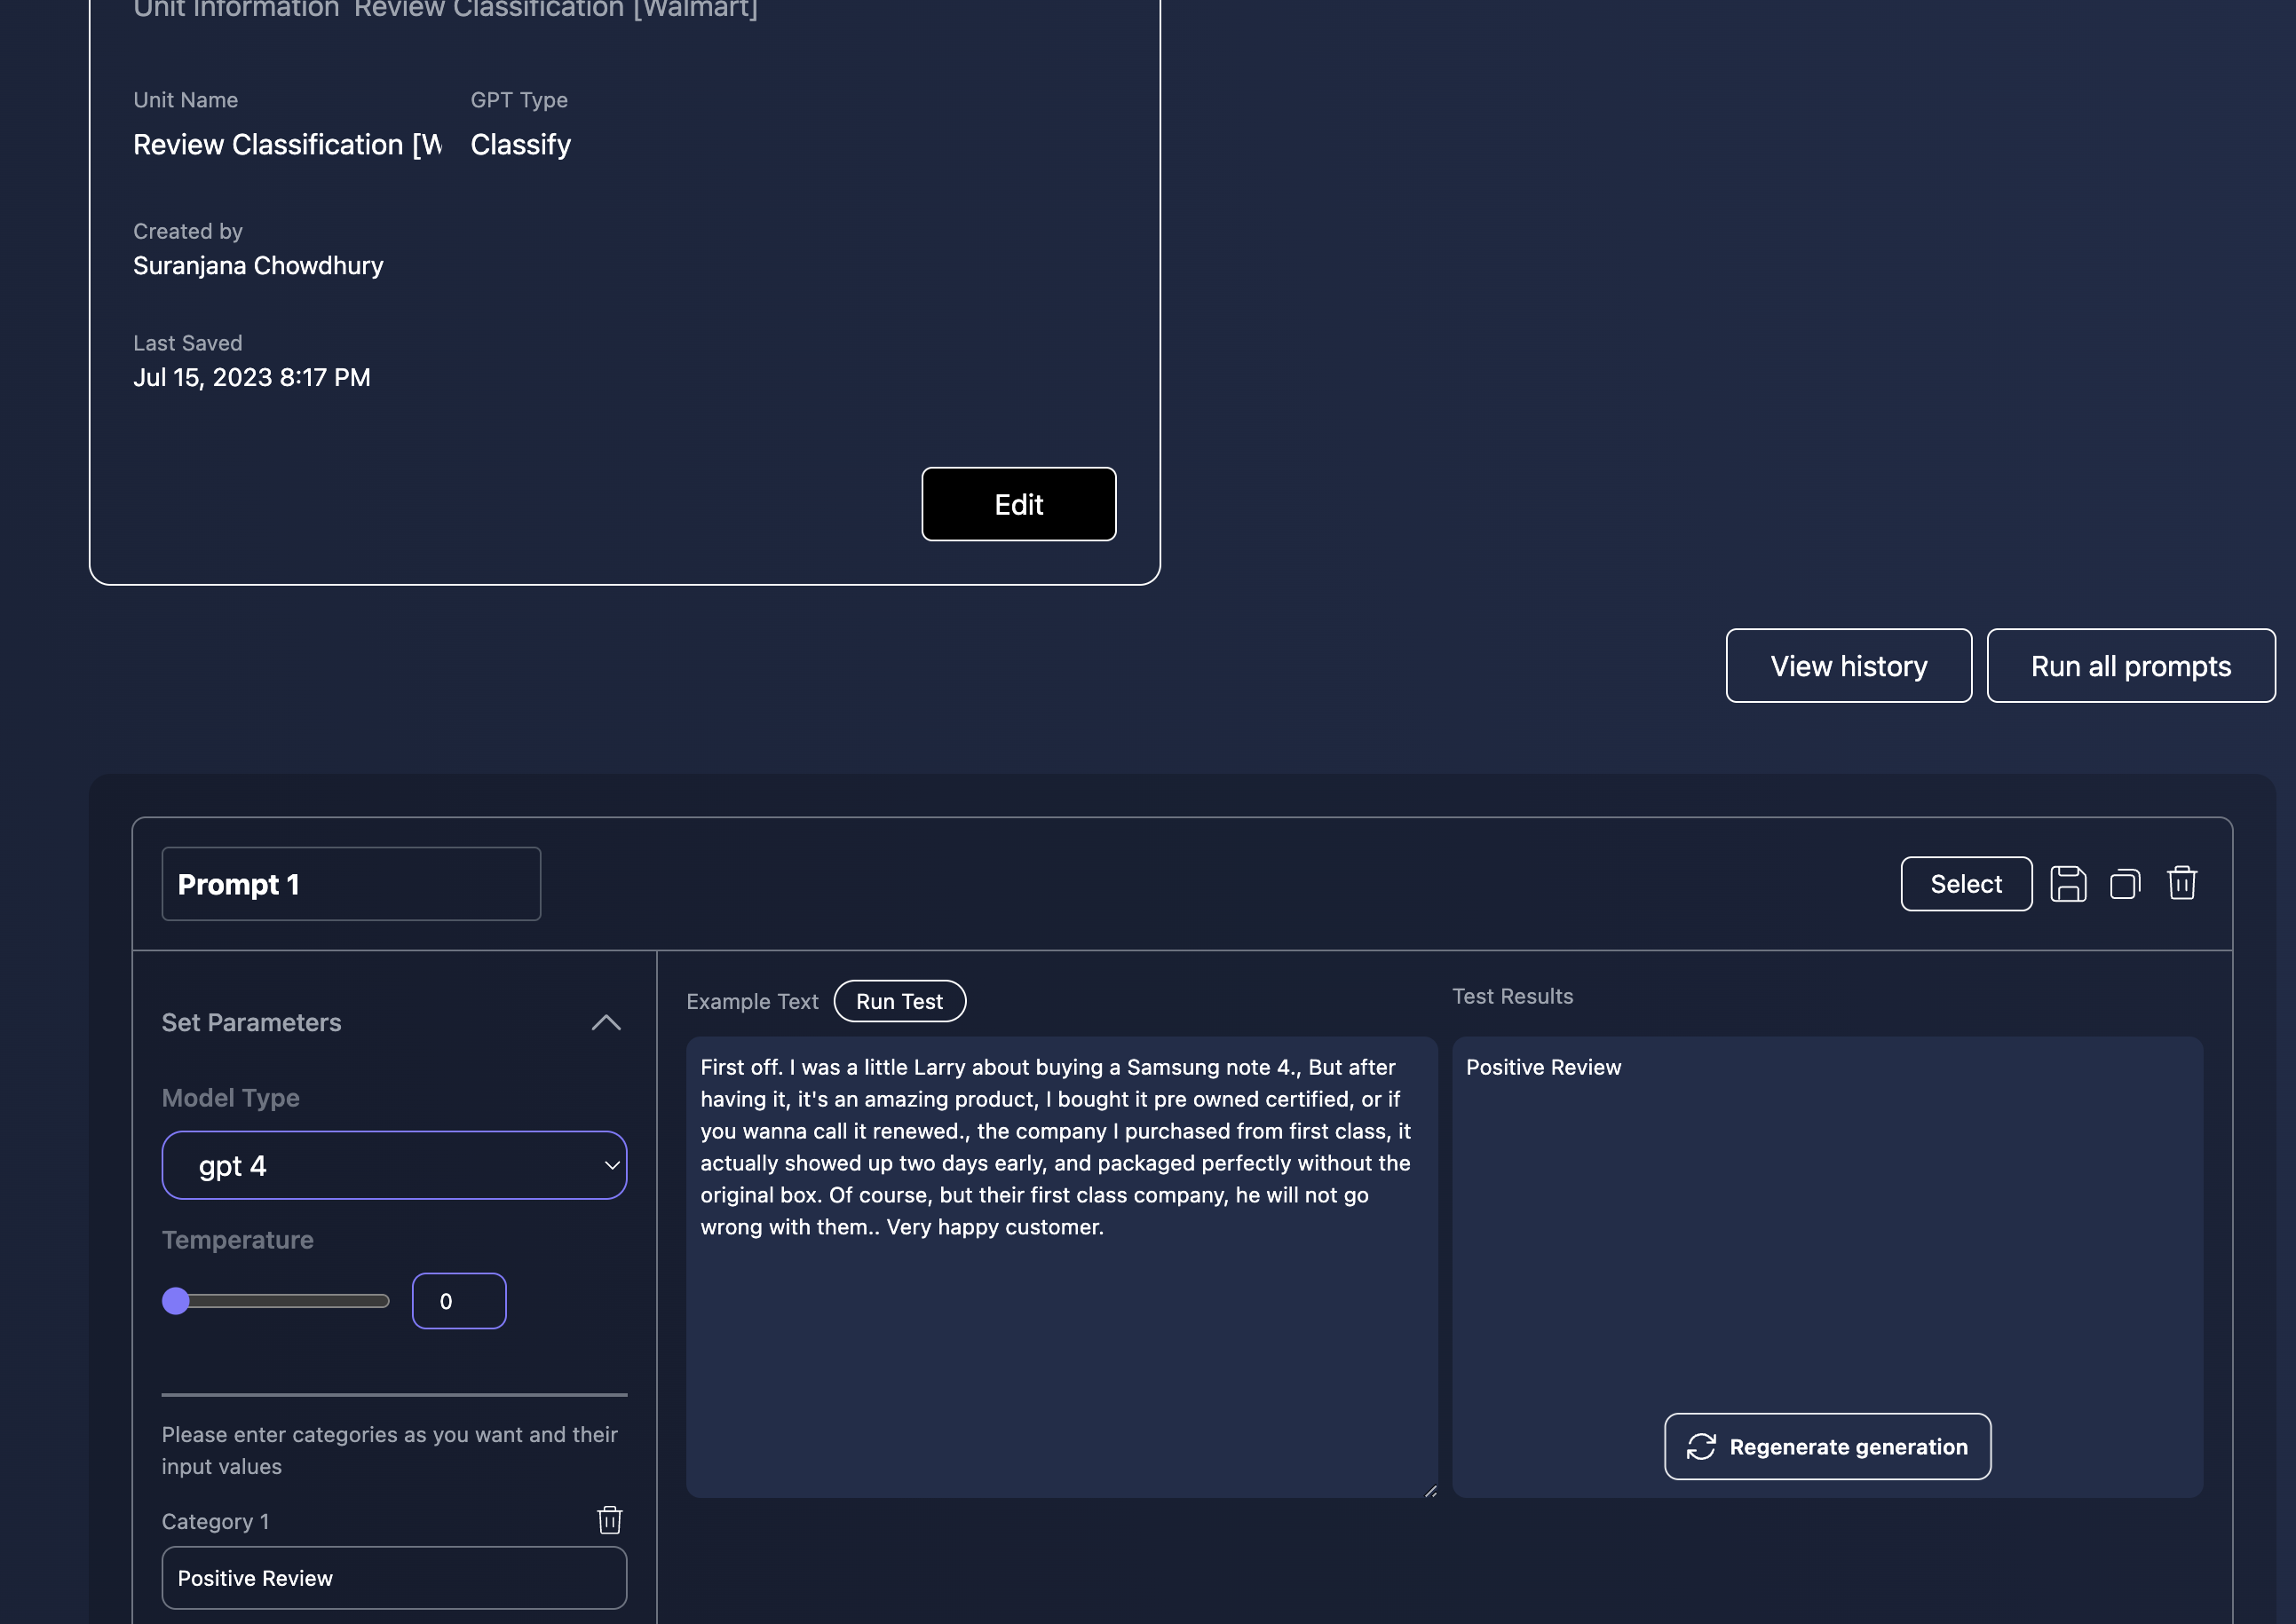

Fig 2: Review classification Walmart Review 1

* **PROMPT 2**

In prompt 2 I created the model,temperature,unit,category as specified above ,similar to prompt 1and fed the below review about a phone-

**Review text 2**

Hi.. I'm so happy , because my phone gets here early and working so good I'll recommend thanks Walmart

**Test Results 2**

The GPT categorized this as Positive review

**Test Result 2 Discussion**

This is correct classification

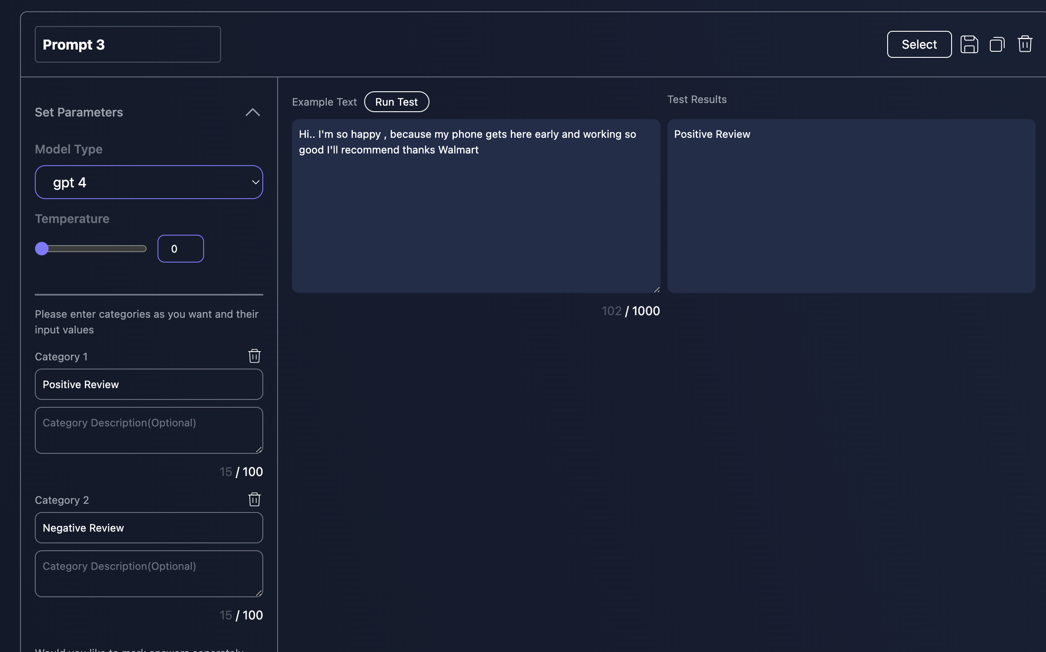

Fig 3: Review classification Walmart Review 2

* **PROMPT 3**

In prompt 3 I created the model,temperature,unit,category as specified above ,similar to prompt 1and fed the below review about a phone-

**Review text 3**

Shipping was fast and reliable. Unboxing the phone for the first time I was amazed at how lightweight and high quality this new model was. Charging was fast and efficient and transferring data from old device to new was seamless and worked well. Brightness and responsiveness is awesome

**Test Results 3**

The GPT categorized this as Positive review

**Test Result 3 Discussion**

This is correct classification

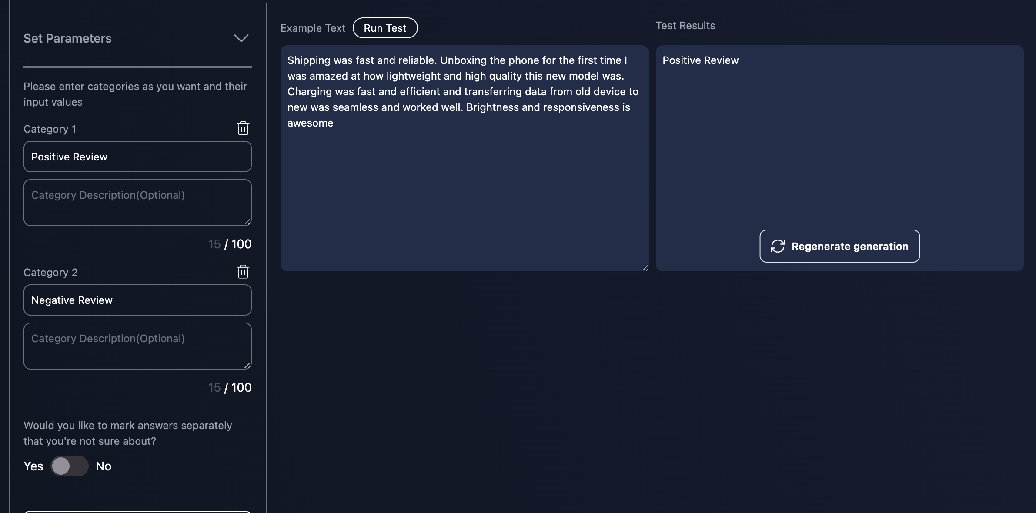

Fig 4: Review classification Walmart Review 3

**NEGATIVE REVIEW**

* **PROMPT 1**

In prompt 1 I created the model,temperature,unit,category as specified above ,similar to prompt 1and fed the below review about a bed frame.

**Review text 1**

I've just assembled my bed and I'm very disappointed, horrible and not naughty to do with the advertising photo. Totally misleading advertising.

**Test Results 1**

The GPT categorized this as Negative review

**Test Result 1 Discussion**

This is correct classification

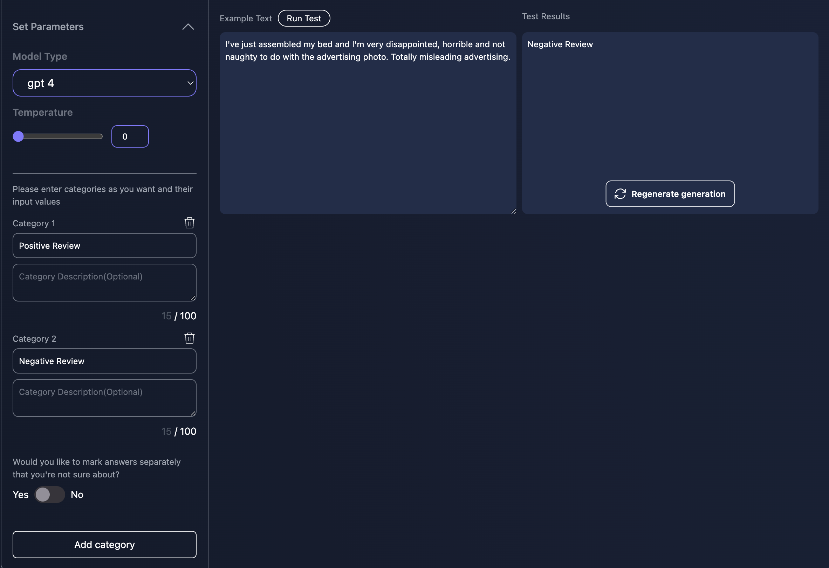

Fig 5: Review classification Walmart Review 4

* **PROMPT 2**

In prompt 2 I created the model,temperature,unit,category as specified above ,similar to prompt 1and fed the below review about a bed frame.

**Review text 2**

i thought this bed was great but I am in the process of buying a new bed as the slates are breaking one after another and the frame is showing its true colors of not beinf sturdy. was great at first and now it's going to the dump. bought march 2022. i don't recommend

**Test Results 2**

The GPT categorized this as Negative review

**Test Result 2 Discussion**

This is correct classification

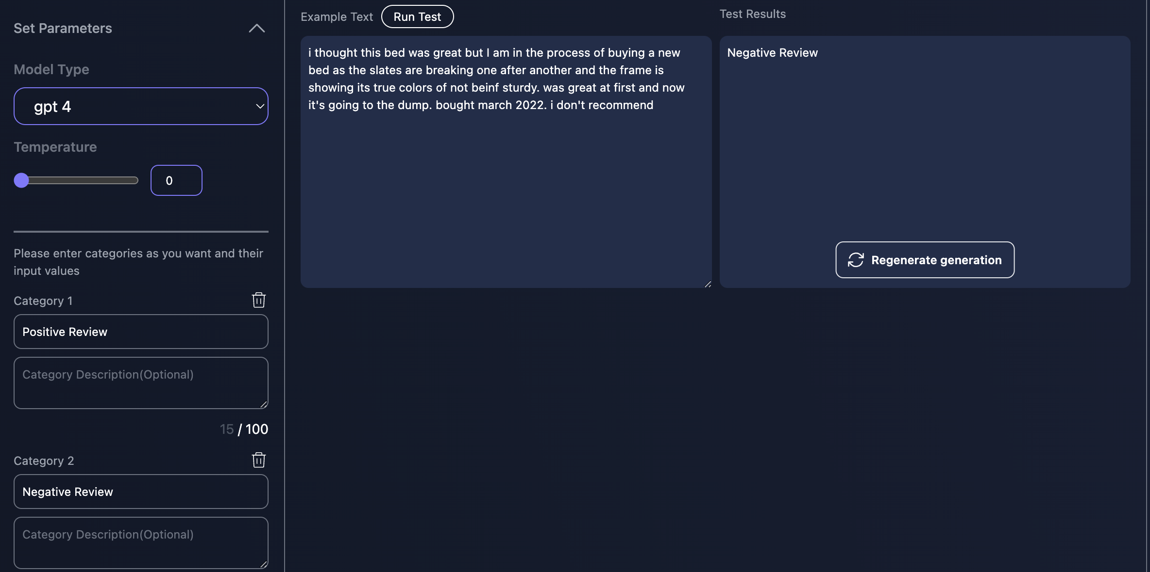

Fig 6: Review classification Walmart Review 5

* **PROMPT 3**

In prompt 3 I created the model,temperature,unit,category as specified above ,similar to prompt 1and fed the below review about a bed frame.

**Review text 3**

This bed frame is only 25 inches high! Like sleeping on the floor. Also, the white stripe on the side in the picture appear to be about 2 inches wide. In reality, it's only about 3/4". The actual bed looks more like a kids race car bed when built. I bought this because of the curved back thinking that would be perfect for sitting up. My mattress is 10 inches and the "headboard" only sits another 2 or 3 inches above the mattress. If I was to guess, I think the original pictures were taken with a 4 inch mattress to give the appearance of being much bigger. The good news is the seller took it back with a full refund no problem!!

**Test Results 3**

The GPT categorized this as Negative review

**Test Result 3 Discussion**

This is correct classification

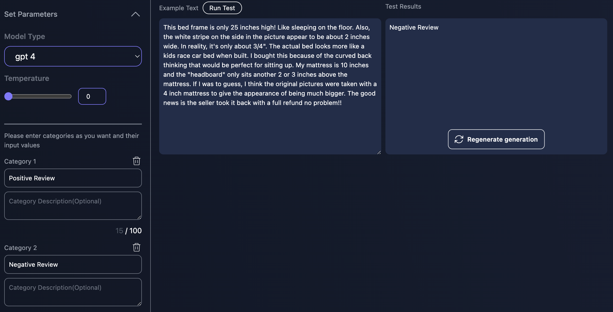

Fig 7: Review classification Walmart Review 6

**GENERATE GPT**

The generate GPT will be used to do **targeted marketing** based on positive reviews. Suppose a user has bought a phone and has given a 4-5 star rating then our generate GPT will send targeted emails to user for accessories like phone cover.

If it is a negative review then the GPT will generate an automated apology email and will give user some promo code that he/she can use to shop later as a token of apology

Here are the settings that I used in Linq

* **Parameter Setting:** used generate from create unit(default)
* **Model Type :** gpt 4
* **Temperature setting :** 0 (as we want LLM to be specific)
* **Embedded document (please attach the actual file with your assignment) :** used prompt text feature of Linq (discussed with every use case below)
* **Input Categories (Minimum of two (2) categories required) :** We have used walmart reviews I.e positive,negative reviews(discussed below in detail)
* **Reason for choosing the categories classification :** We are interested in positive negative reviews I.e. polar reviews such that we can implement targeted marketing in case of positive review promos in case of negative review and deply the workflow units in later stages of deployment

-Let us see the **three** variations of generate GPT

* **PROMPT 1**

In prompt 1 I created the model,temperature,unit,category as specified above ,similar to prompt 1and fed the below review text

**Review text /Input Text**

At first I thought it was great but soon after I realized that I may have made a mistake. It keeps losing its Wi-Fi connection and unfortunately it doesn't have Face ID or a touch screen. Also, the trackpad is plus/minus. I can't make phone calls either, although I thought I could link it with my Apple iPhone and make phone calls and use FaceTime and Facebook but no such luck.

- The review is {input1} , Additionally to make the email look personalized we inputted user name as {input2}

**System Message 1**

You are a seller on ecommerce site walmart. You need to respond to negative reviews. Be very polite,kind,professional

**Prompt Text 1**

Write a response to {input1} which is a negative review written by {input2} following below guidelines.

1.Keep the length within 20 sentences

2.Make sure to thank {input2} for being valuable customer

3.Thank for providing the valuable feedback

4.Act like a customer service agent

5.Do not write Your Name as you are a customer agent

6.Apologize and ensure you are trying to improve your products and give customer a promo for next purchase

**Test Results 1**

The GPT generated an apology email like below:

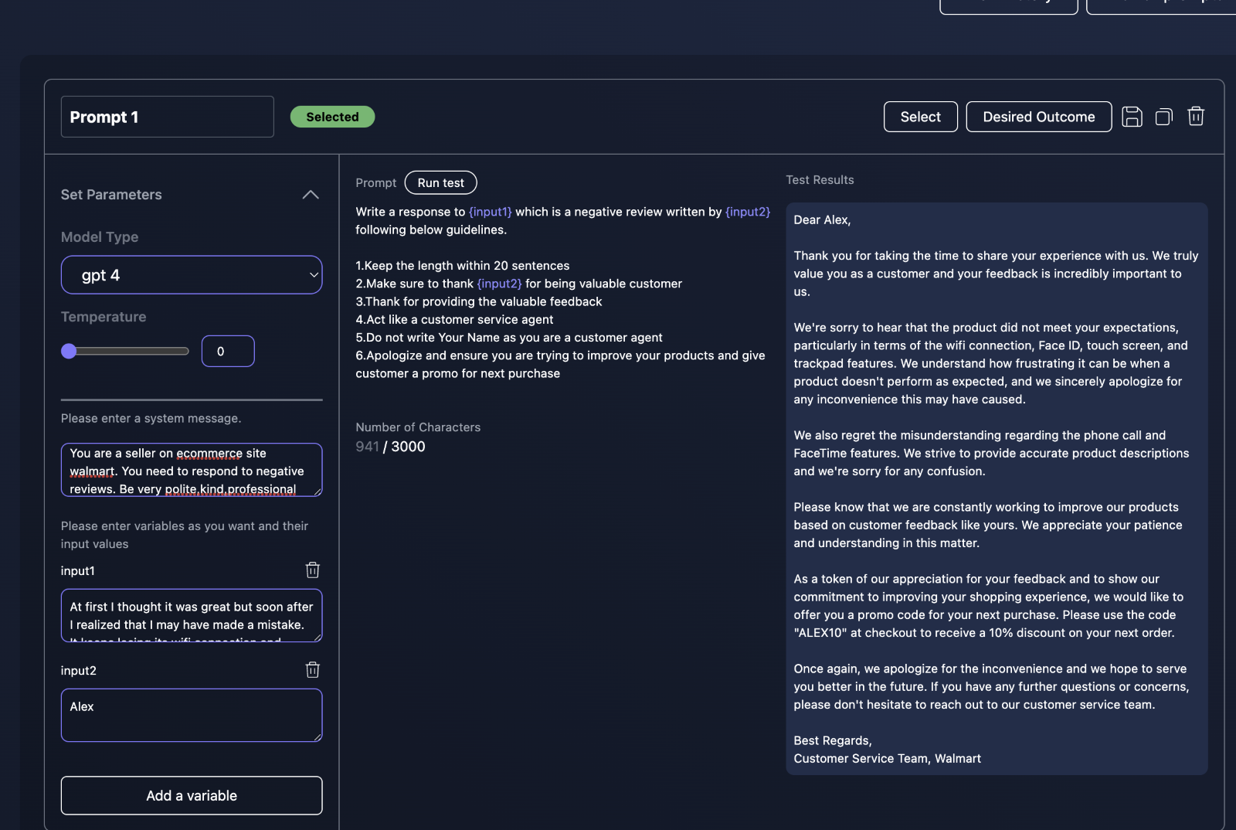  
Fig8: Test 1 for generate GPT for Negative Review

**Test Result 1 Discussion**

* As we see the GPT articulated our input very well. I wrote an apology mail,made it look sincere and did not write a name as it is acting like a customer representative of walmart.
* It reflected on the review and acted sympathetic to the customer
* It gave a promocode ALEX10 which is quite impressive as I did not mention exclusive promos in the instruction.

-Let us see how it generates email for positive review

* **PROMPT 2**

In prompt 2, I created the model,temperature,unit,category as specified above ,similar to prompt 1and fed the below review text about laptop from walmart’s site

**Review text /Input Text**

like it so far it’s a bit slow and u can play sims 4 on it and 13.3 is the perfect size

-The review is {input1} ,Additionally to make the email look personalized we inputted user name as {input2}

**System Message 2**

You are a seller on ecommerce site walmart. You need to respond to positive reviews. Be very polite,kind,professional

**Prompt Text 2**

Write a response to {input1} which is a positive review written by {input2} following below guidelines.

1.Keep the length within 20 sentences

2.Make sure to thank {input2} for being valuable customer

3.Thank for providing the valuable feedback

4.Act like a customer service agent

5.Do not write Your Name as you are a customer agent

6.Ask user to shop again and keep an eye for Black friday /cyber monday deals

**Test Results 2**

The GPT generated a thank you email like below:

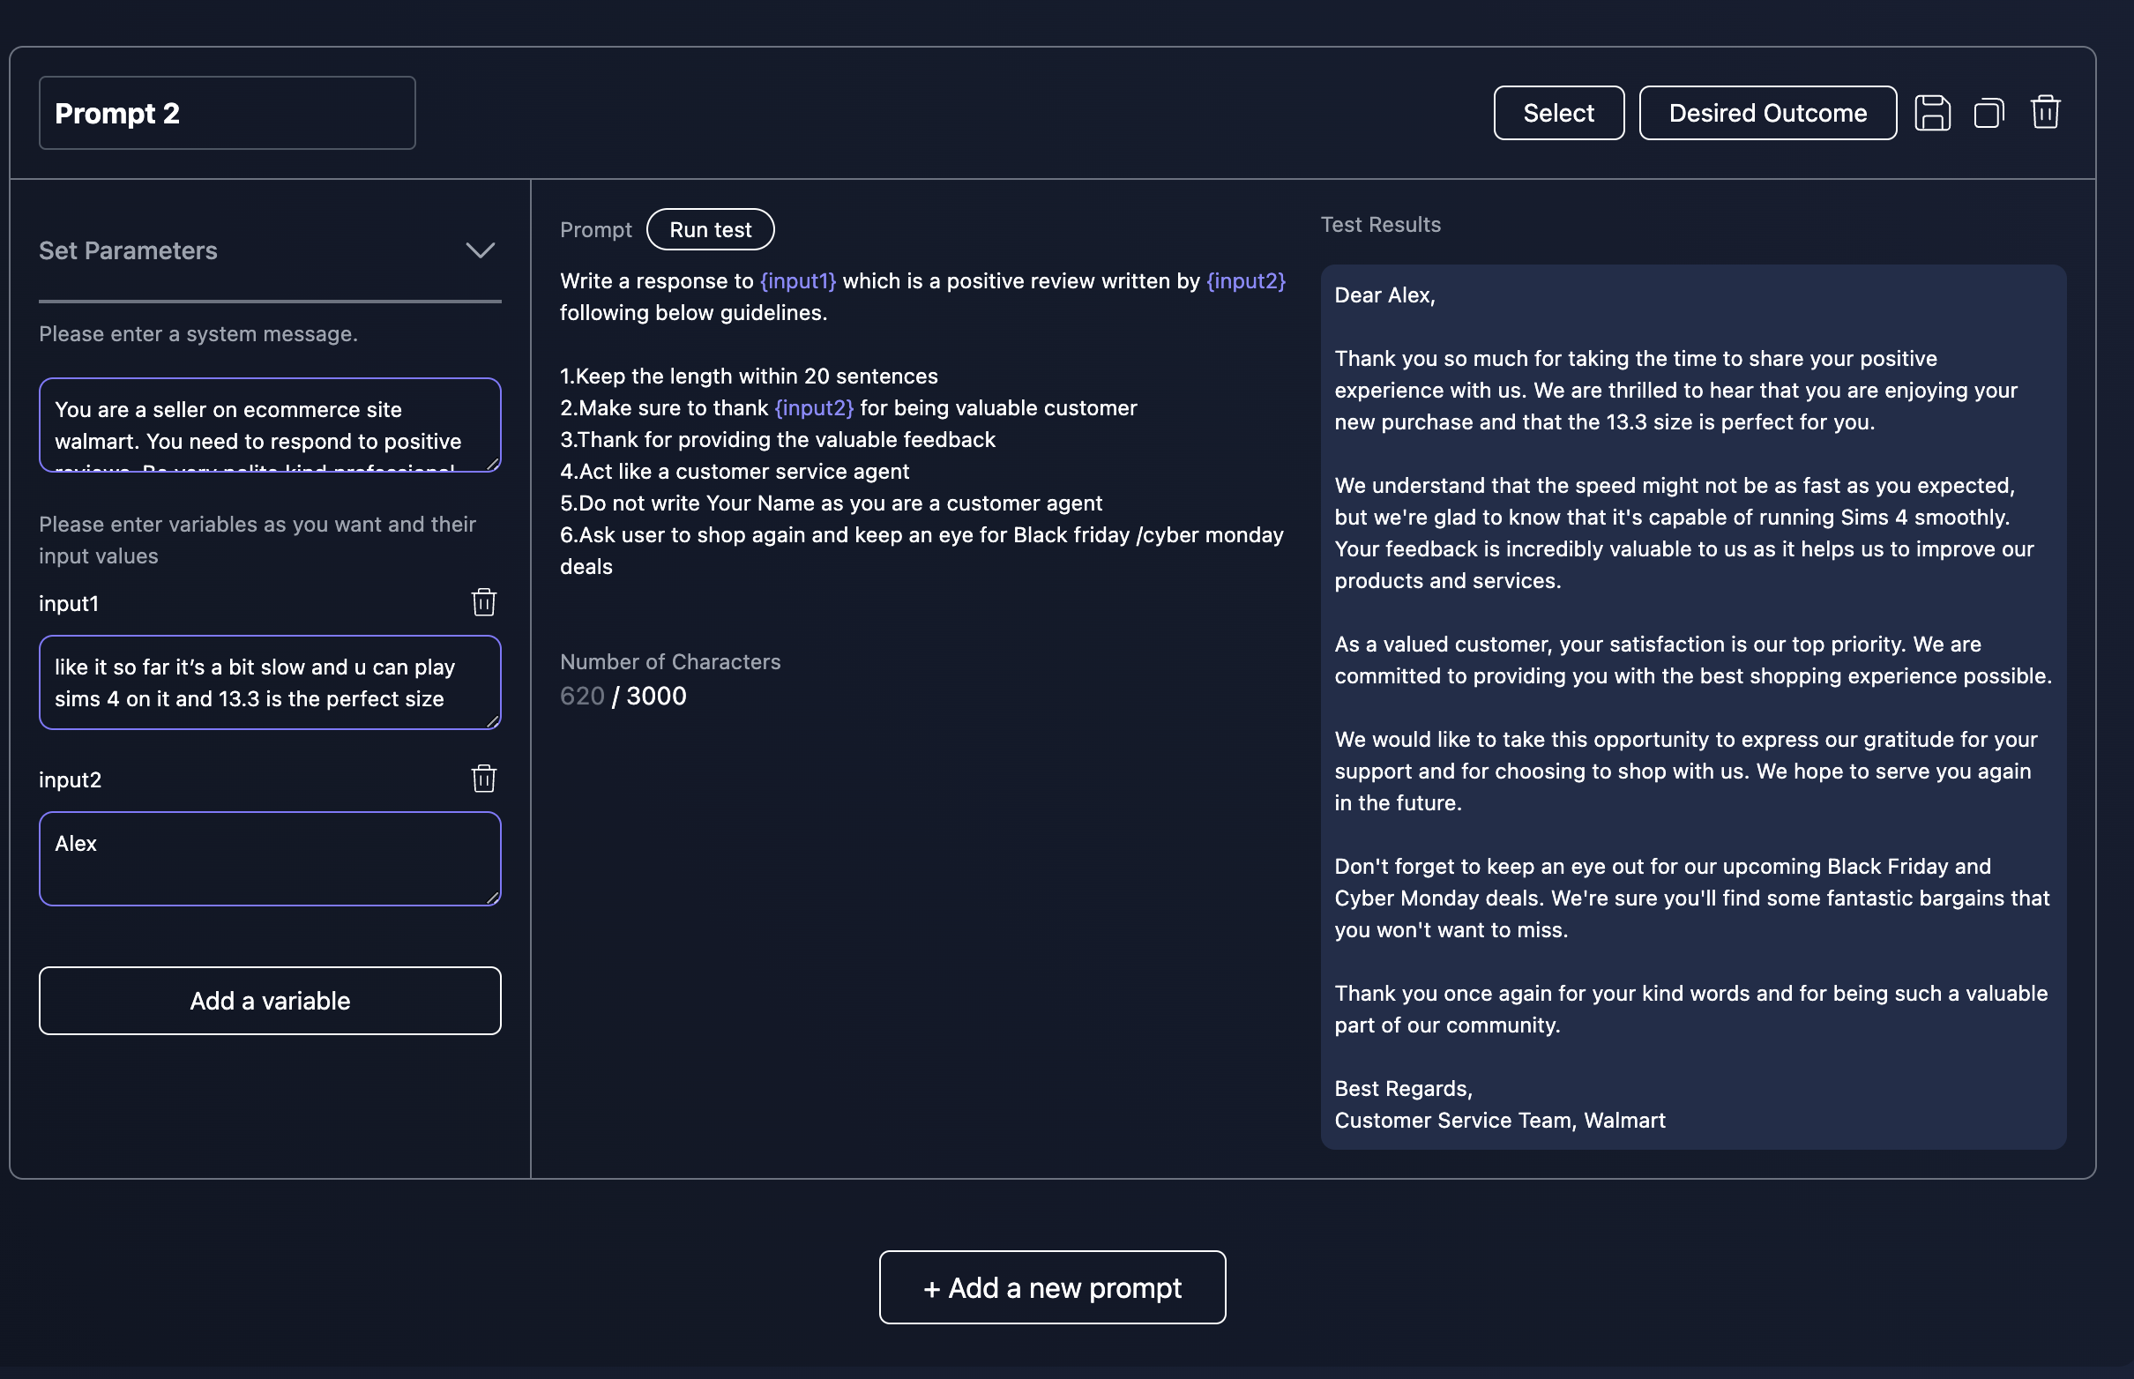

Fig 9: Test 2 for generate GPT for Positive Review

**Test Result 2 Discussion**

* As we see GPT has generated a thank you email and it has added a personal touch by using the given input.
* It also gave a gentle reminder to user to watch out for black friday ,cyber monday deal as instructed
* Overall this looks very sincere and professional
* **PROMPT 3**

In prompt 3, I created the model,temperature,unit,category as specified above ,similar to prompt 1and fed the below review text about mobile from walmart’s site

**Review text /Input Text**

walmart got my iphone here in just 3 days! came in perfect condition! never hesitate when purchasing a phone solely from walmart because they always ensure you will get what you ordered! 10/10

* The review is {input1} ,Additionally to make the email look personalized we inputted user name as {input2} and to **suggest related product for targeted marketing I have used {input3}**

**System Message 3**

You are a seller on ecommerce site walmart. You need to convince a person who has given positive review to buy a related product.Be very polite,kind,professional

**Prompt Text 3**

Write a response to {input1} which is a positive review written by {input2} and convince customer to buy {input3} following below guidelines.

1.Keep the length within 20 sentences

2.Make sure to thank {input2} for being valuable customer

3.Thank for providing the valuable feedback

4.Act like a customer service agent

5.Do not write Your Name as you are a customer agent

6.Explain to user why he should avail the item you want to sell

7.Ask user to shop again and keep an eye for Black friday /cyber monday deals

{input3}

**Test Results 3**

The GPT generated a custom email like below:

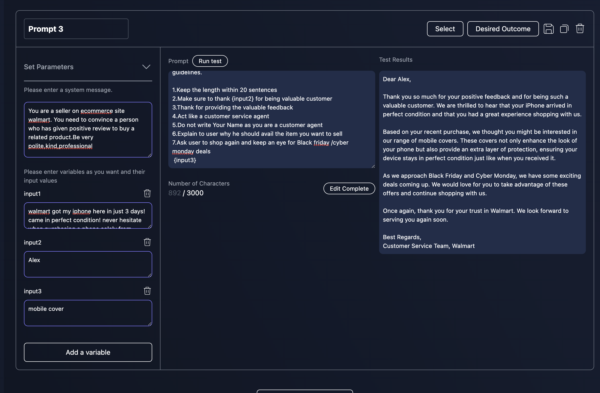  
Fig 10: Test 3 for generate GPT for custom email for targeted marketing

**Test Result 3 Discussion**

* The GPT thanked user for being a valuable customer and then suggested user to consider buying a mobile cover.
* It gave the reason for the suggestion (here mobile cover)
* The mail adds a human touch and is proffesional

**DEPLOYMENT**

After creating separate units I deployed the classify unit (positive negative review) and the generate unit(positive review generate email, negative review generate email and promo code generate).

* We give 3 inputs - The review is {input1}
* Additionally to make end results look personalized we inputted user name as {input2}
* To **suggest related product for targeted marketing I have used {input3}**

We have one classify and 3 generate units in the deployed model. There is input I.e starting point and post that the classify GPT classifies and if Positive it generates a targeted marketing email , I.e sends it to another generate GPT and if negative there is an apology email

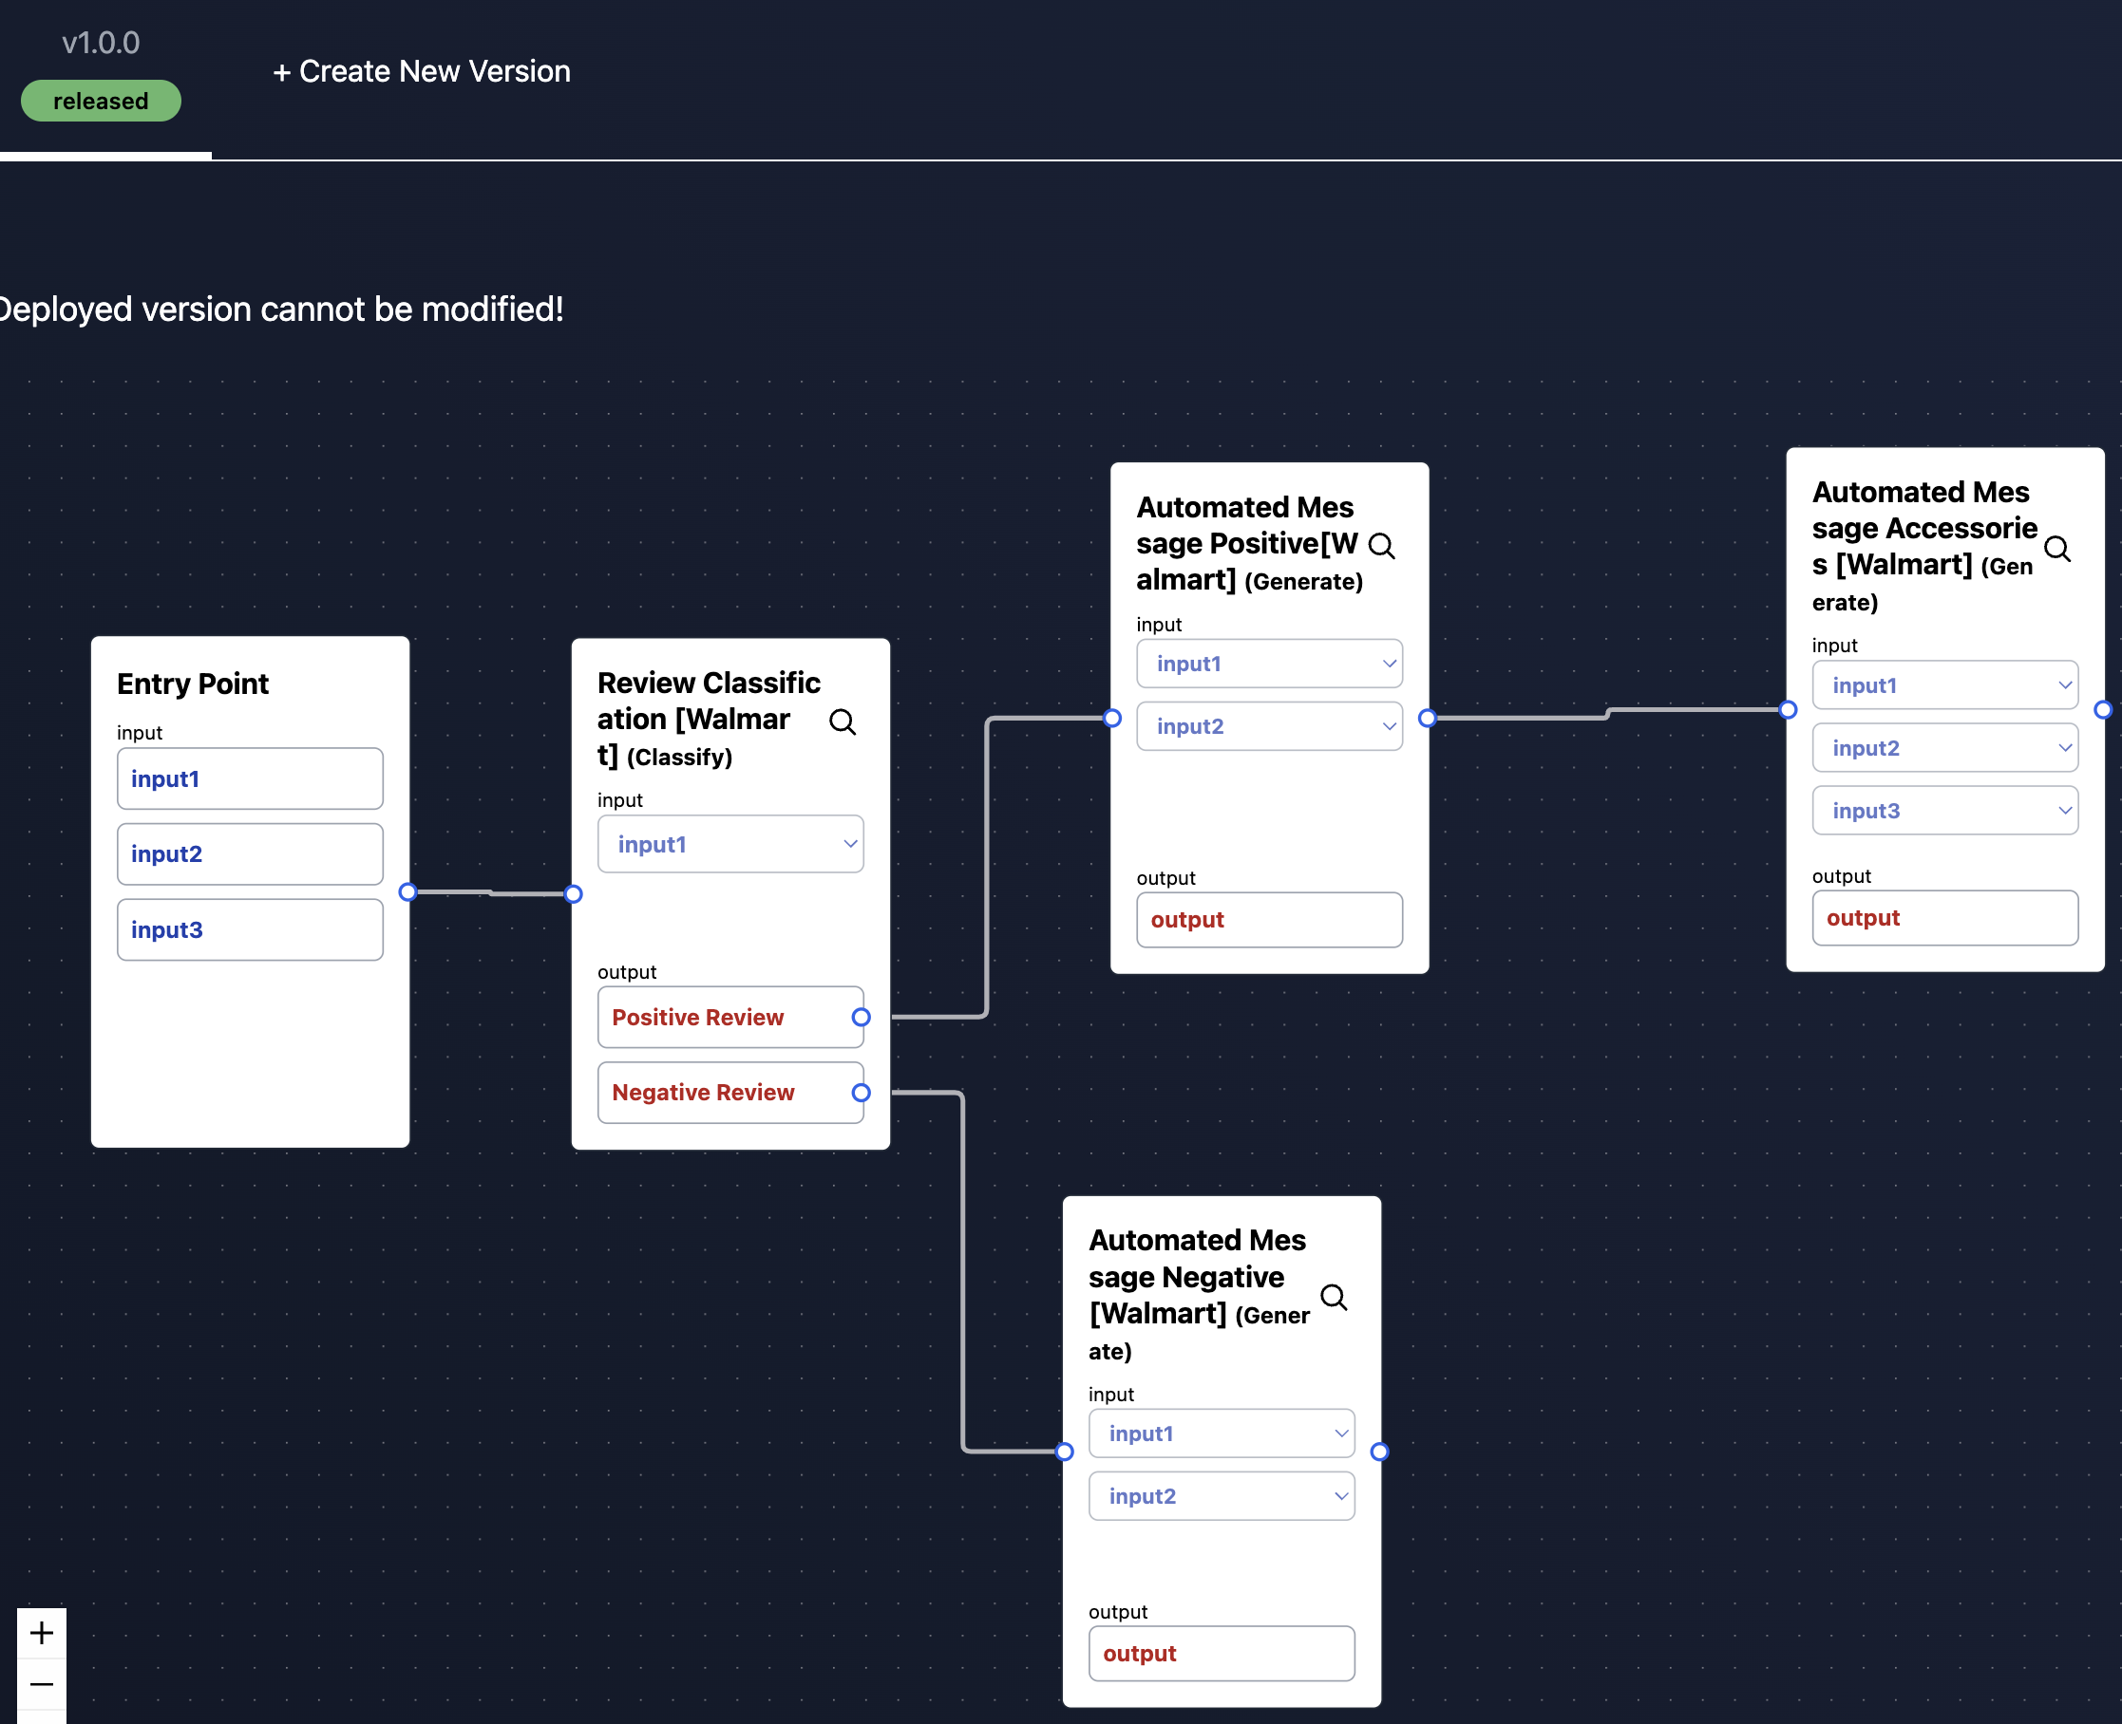

Fig 11: Deployment of generate,classify units

Here is a demo of the working model:

* Negative Review

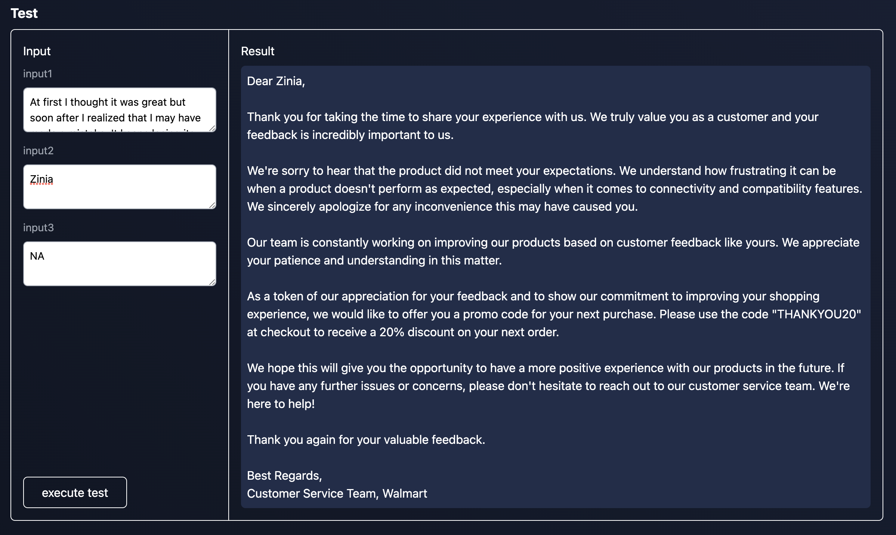

Fig 12: Deployment of generate,classify units and result for Negative review

* Positive review

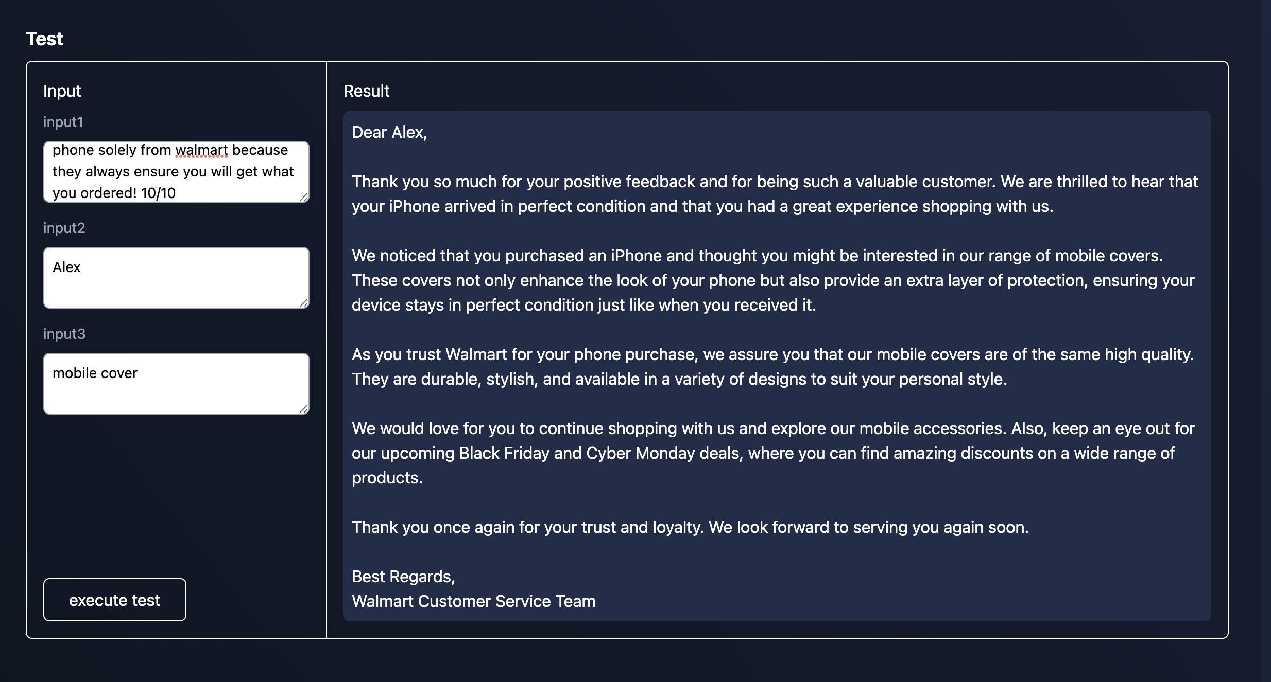

Fig 13: Deployment of generate,classify units and result for Positive review

**CONCLUSION**

By using LLM bots a personal shopper and these generate classify GPT walmart can automate and streamline customer support and tackle its competitors like amazon and target

**REFERENCE**

[1] Linq-[**https://wecoverai.notion.site/Linq-App-Instruction-Manual-7582e2499db749508e54eaffad36d25b**](https://wecoverai.notion.site/Linq-App-Instruction-Manual-7582e2499db749508e54eaffad36d25b)

[2] Market share of leading retail e-commerce companies in the United States as of June 2022- <https://www.statista.com/statistics/274255/market-share-of-the-leading-retailers-in-us-e-commerce/>